SHED DIVISION MOCK EXAMINATIONS
2026 MALAWI SCHOOL CERTIFICATE OF EDUCATION
BIOLOGY
PAPER II
(Practical)
Subject Number: M022/II
PROVISIONAL MARKING SCHEME
1. The marking scheme is not final
2. Answers can be added or modified
3. Use relevant books or sources to supplement or modify the answers

Section A (20 marks)
Question one.
- Obtain 100 maize seeds and 100 pea seeds
- Place the seeds into one container (1)
- Mix the seeds in the container by shaking the container (1)
- Place the mixed seeds on a table
- Divide the seeds into ten portions randomly (1)
- Pick one group randomly and count the number of maize seeds and pea seeds in that group (1)
- Determine the estimated number of maize seeds and pea seeds by multiplying by 10 (1)
- Put the seeds in one container again, shake and put on a table (1)
- Divide the seeds into five portions randomly. (1)
- Pick one group randomly and count the number of maize seeds and pea seeds.(1)
- Determine the estimated number of maize and pea seeds by multiplying by 5 (1)
- Compare the results of the two. A larger sample produces estimated number closer to the actual value. (1)

Question 2
- Cut three pieces of liver and shape them into 3 cubes (1)
- Put equal volumes of hydrogen peroxide into three test tubes labelled A, B and C. (1)
- Cut one cube into 4 equal pieces.
- Crush the second cube using a pestle and a mortar (1).Leave the third cube intact (1)
- Set a stop watch (1)
- Place the intact cube in test tube A and start the stop watch (1).
- Record the time taken for foam produced to rise up to the brim (1)
- Repeat procedure above or the cut cube and crushed cubes by placing them in test tubes B and C respectively.(1)
- Shorter time for the foam to reach the brim will be observed in test tube C.(1)
- The smaller particles the particles, the faster the rate of enzyme activity (1)

Question 3

a. Table 1
Length of leaf (mm) | 0 – 70 | 71 -90 | 91 - 170 | 171 - 220
Number of leaves (frequency) | 2 | 3 | 4 | 3
1 mark for each length (4 marks)
b (i) continuous variation (1 mark)
(ii).
- length has intermediate forms
- shows smooth graduation through lengths
any one (1 mark)
(iii) 91-170 mm (1 mark)
(iv)
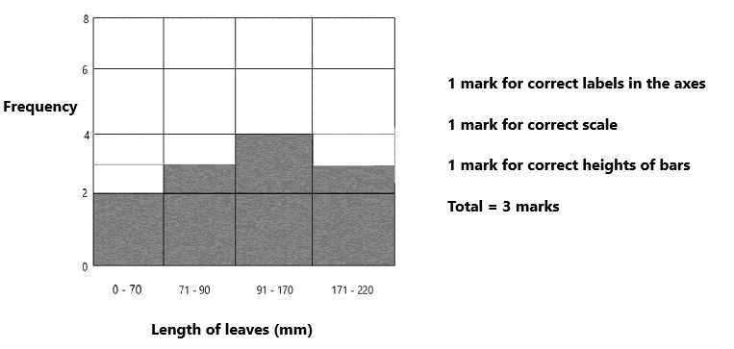

Question 4

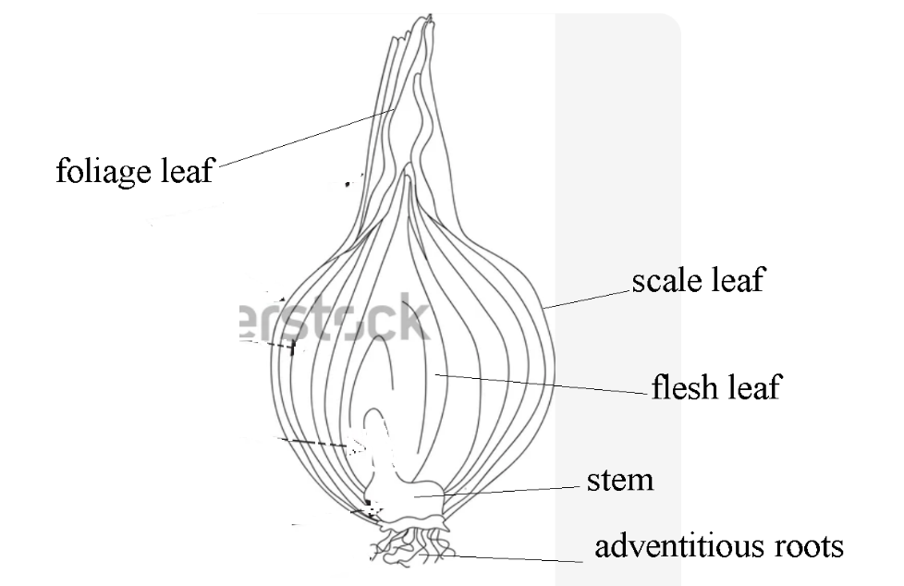
(Any 4 x1)
- (i) 150 -250mm (1)
(ii) $Magnification=\frac{length of drawing}{length of specimen}$
$= \frac{x}{150mm to 125mm} \left(1\right)$
$$=correct answer (1)$$
- Vitamin A, Vitamin B₆, Vitamin B₉
Potassium, Manganese
Proteins, fats, water

( any two for 2 marks)

